LEARNING GOALS 1 TUTORIAL

learning goals:
- What are random/real; directed/undirected networks and what are the differences between them?
- When do we use directed graphs/networks and when do we use undirected graphs/networks in modeling?
- What is the Central Dogma?
- How does cancer work on a genetic level? (different classes)
  - What is its relation to the hub node system? (10 hallmarks of cancer paper)
- how does the knowledge of the task help to develop insight into how cancer works and its possible therapeutic strategies
- Why do hubs tend to be essential in biological networks? (have definitions for the terms used in the lectures centrality, betweenness etc.)

  - Networks are made up of nodes (metaphor for people) and edges (their relations). Edges additionally can point out the direction of the relation, If it’s from A to B or from B to A, these are considered directed networks, if no direction is specified the relation is assumed to be A to B AND B to A and such networks are undirected. Random networks are assumed to be random, i.e there’s a normal distribution between the relations(number of edges, described as the degree of the node) of node I to node J, for all nodes I and J j st J!=I. Real networks are assumed to not follow this distribution, it can be a reliable test of the desired network , to check against randomness.

  - Directed graphs are the most general kind of graphs because they don’t impose the restrictive assumption of symmetry in the relationship modelled by the edges, edges represent causality or hierarchy. Whereas undirected graphs assume symmetry, they are highly used in the topology of social networks as we assume if Daan is friends with Tina, Tina also considers Daan as a friend.

  - Central dogma. The central dogma of molecular biology is a theory (Francis Crick, 1958) stating that genetic information flows only in one direction, from DNA, to RNA, to protein, or RNA directly to protein.

  - Cancer is a genetic disease, caused by changes in genes that control the way cells grow and multiply (), if the genes alter, the “instructions” of how to behave (reproduce etc) variate and an accumulation of genetic changes over many years can turn healthy cells into cancerous cells. The changes can happen randomly, inherited from parents or by carcinogens as smoking or UVrays. Hub nodes are the nodes of a network with the highest degree. Cancer cells actually somehow convince the immune system to help the tumor spread.

From the image :
Blue text - what cancer does
text boxes - ways to prevent cancer - therapeutic perspectives (from tutorial notes)

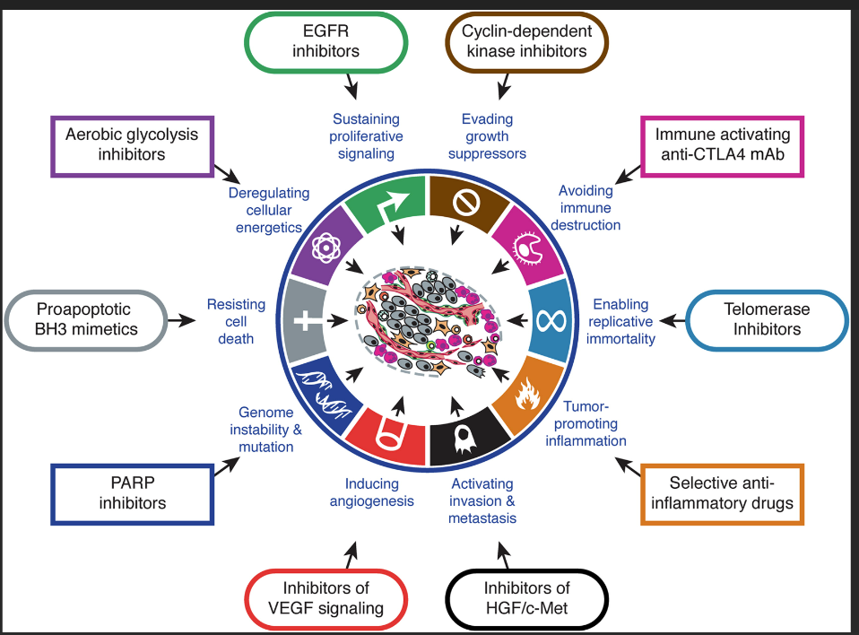

  - We can visualize the interaction of our human cells as a network, the edges would represent some process between two cells. A cancer-based example is how the transcriptor factors promote or inhibit such protein that can be used to make cells die.

  - Hubs tend to depict essential genes, cells, or processes. Because for these nodes, when computing all shortest paths for all nodes I &J s.t J != I, this hub node tends to be the most present, meaning that for any process between node I and J, hub node H will also be required to happen/exhibit etc. Also, hubs nodes have a high closeness coefficient given by its connectivity to all other nodes, meaning that for most of the nodes in network n, node H is a close neighbour of them, this can be interpreted that such cell node H represent is needed for the desired process.

In terms of cancer, I assume that such nodes should be inspected the first and by them further understand the stage of the disease or what is it affecting currently.

What Is the Difference Between a Directed and an Undirected Graph | Baeldung on Computer Science
Central Dogma (genome.gov)
The Genetics of Cancer - NCI
Cancer in Lymph Nodes May Help Tumors Metastasize - NCI
Hallmarks of Cancer: The Next Generation: Cell

